**IMPLEMENTING WEB APPLICATION**

|  |  |
| --- | --- |
| Date | 07 November 2022 |
| Team ID | PNT2022TMID22996 |
| Project Name | Plasma Donor Application |

**SETTING UP FLASK MODULE:**

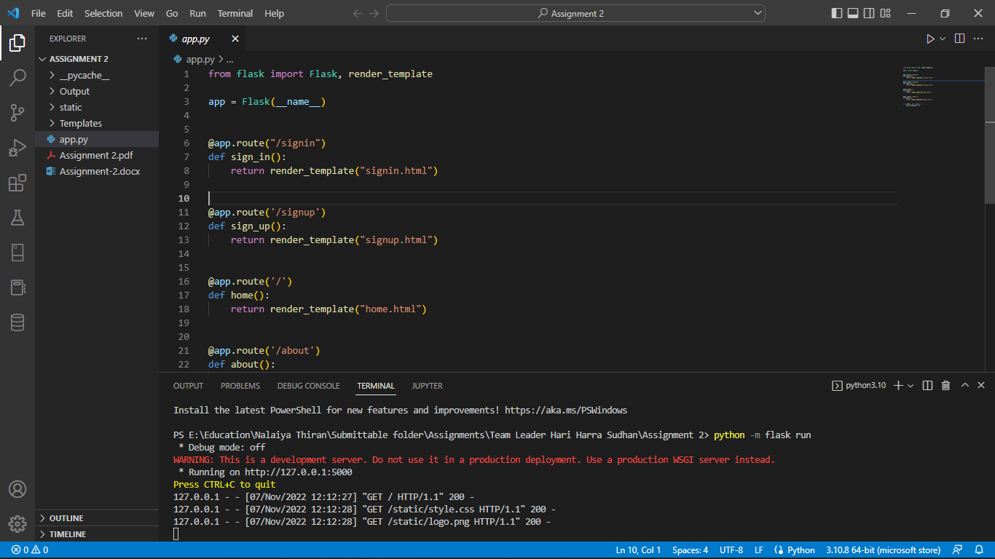

**UI OF THE APPLICATION:**

